

|  |  |  |  |  |  |
| --- | --- | --- | --- | --- | --- |
| Programme | : | **B.Tech (CSE)** | Semester | : | **Fall 2016** |
| Course | : | **Internet and Web Programming (Embedded Lab)** | Code | : | **CSE3002** |
| Faculty | : | **Prof. Rajiv Vincent**  **Prof. M.Premalatha** | Slot | : | **L7+L8** |

**Ex. No: 5**

**Date: 16/8/16**

**Javascript with Forms and Validation**

Form Design:

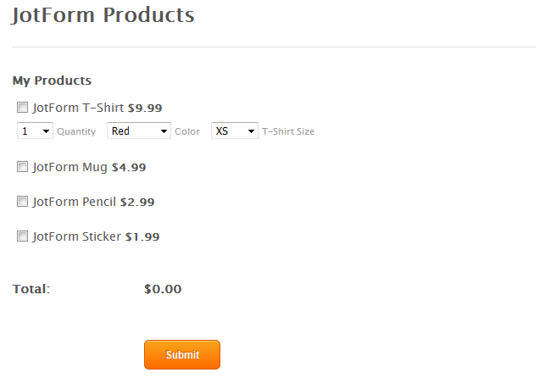

Form Design Constraints:

* Total should be generated based on the number of checks in the check boxes, which sums the amount specified.
* For T-Shirt, Quantity to be set from 1 to 5
* For T-Shirt, Colors are Red, Green and Blue
* For T-Shirt, Sizes are XS, S, M, L, XL, XXL
* Add a coupon code text box before submit button

Coupon Code Generation:

Online shopping website had a plan to generate a unique coupon code for their customers which they can use during checkout. For which they request the customer to enter either 7 or 8 character username through a text box.

* If it is a 7 character string, the characters generated for the coupon code are as follows:
  + 1 – First character of the username in uppercase
  + 2 – Count of the number of vowels in the username
  + 3 – Last character of the username
  + 4 – Any special character
  + 5 – Count of the non vowels in the username
* If it is a 8 character string, the characters generated for the coupon code are as follows:
  + The characters which appears in 1 to 10 positions in the English Alphabet in the username sequence.

Write a JavaScript Code and display

* The Billing amount without applying discount
* The amount to pay by giving a 10% discount on the bill amount after applying a coupon code
* If the amount to pay exceeds 10$ after applying discount, give an extra 10% discount and display the amount to pay.
* Display the product details with the least and the greatest amount selected for billing.
* Display the product details which is not selected for the billing.